*Florida International University*

*School of Computing and Information Sciences*

Software Engineering Focus

Feature Document

User Story ID 799

**Name:** Display Devices Battery Level Graph

**Team Member(s):** Leandro Gonzalez,Luis Herrnsdorf

**Project:** Smart Stormwater (Smart City System) 2.0

**Product Owner(s)**: Emilio Lopez

**Mentor(s)**:

**Instructor**: Masoud Sadjadi

**User Story Name:**

* Description: As a User, I want to be able to see a graphical representation of the battery level of devices assigned to me, so that I am able to see when a device battery has drained

Acceptance Criteria

* The graph is located on the Main Dashboard page
* X-axis contains all devices assigned to the user
* Y-axis contains the battery level of the devices

**Use Case**

* Name: View Battery Level Graph
* Actor: User
* Preconditions: User is logged in
* Description: Anywhere in the app, the user clicks on the ‘Dashboard’ tab on the side panel. User is redirected to the Dashboard page, which contains a bar graph that represents the battery life of all the devices assigned to the user. The x-axis contains the names of all devices, while the y-axis contains the battery level of each device

**Use Case Diagram**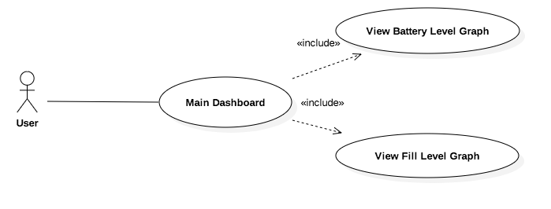

**Sequence Diagram**

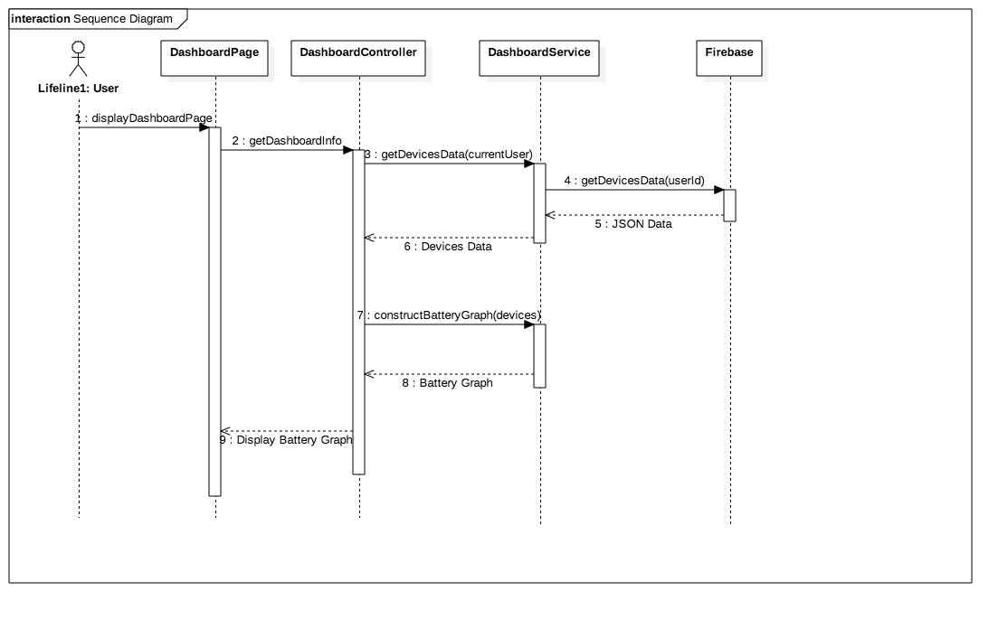

**Class Diagram**

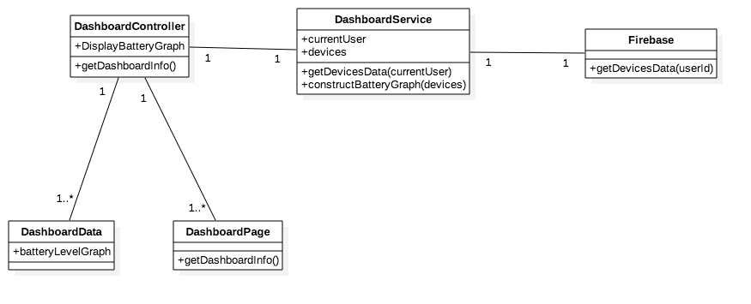

**Unit Test**

* Test case ID: ViewBatteryLevelGraph
* Description/Summary of Test: User navigates to dashboard page to view graph containing battery level of all his/her devices
* Pre-condition: User is logged in
* Expected Results: Battery Level Graph is accurate
* Actual Result: Battery Level Graph displays the correct battery level of all the user’s devices
* Status (Fail/Pass): Pass

**Visual User Guide**

